**Project Description (Access and Testing instructions append at the end)**

**Introduction**

The starting point of this project was to build tools/apps to assist in solving complex climate change problems at Great Lakes with cross-disciplinary perspective. The **problem at question** selected here is how does the Great Lakes climate changes the lake water temperature and/or level, and if this relationship is also effected by the amount of vegetation within the boundaries of the Great Lakes’ watersheds. Selection of this problem was inspired by an [article](http://archive.jsonline.com/news/wisconsin/does-lake-michigans-record-low-water-level-mark-beginning-of-new-era-for-great-lakes-216429601.html), which suggested that the great lakes water temperature is related to the decreasing water level due to increasing sun absorption due to lacking ice covers in winter. The need to link vegetation data was kindly confirmed by Dr. Roehm at Terralimno LLC. through email (Please see at the end of this document). Also, recent remote sensing development have now enable us to build a brand new tool to help in investigate the problem in question, which was not possible before.

In order to solve the problem in question, one need to realize that it is a very complex issue (Figure 1), one cannot ignore such complex relationship between each component. Thus, it is vital to have a holistic approach to investigate such climate change problem at the Great Lakes.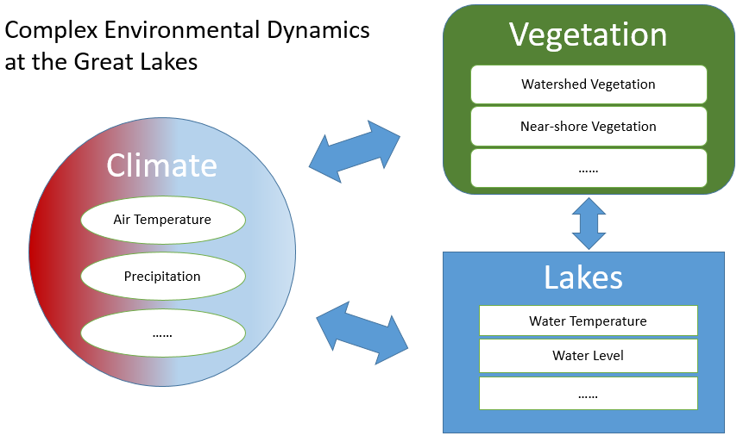

*Figure 1. Complex Environmental Dynamics at the Great Lakes*

In order to make this approach work, one needs all data related to the Great Lakes vegetation, lake water and climate before conducting sophisticated data analysis and draw meaningful conclusions. This project was set out to assist in the investigation process of the problem in question by creating an easy-to-use and interactive environment for one to easily begin his/her investigation and to promote the efforts of possibly understanding and better planning for the problem in question.

**Target User Needs**

This project aims at several user needs which we believe are vital to investigate the problem at question. These user needs include: 1. Open and free access to everything, which includes all developed apps and all data utilized. 2. One-stop-shop and interactive app without using an additional link to other datasets. 3. Need to bring in cross discipline dataset, such as NDVI (Normalized Difference Vegetation Index) from the field of remote sensing. 4. Easy and on-the-fly data explorations and visualizations with no programing knowledge needed. 5. Easy and quick data export options, which increase compatibility of developed apps with other data analysis software, as well as to promote further complex data analysis based on outputs from the developed apps.

**Project Objectives**

Primarily, this project was set out to gather all available environmental data within the categories of climate, lake water data and vegetation indexes related to the Great Lakes environmental. Climate and lake water data were extracted from GLOS buoy dataset, and vegetation index data was extracted from various NDVI datasets from Landsat 5, 7 and 8.

Secondly, this project aims to develop a tool to promote and assist in downstream data analysis. Thus, the project scope was limited to data exploration and data visualization (Figure 2). All data gathered are put into one developed interactive environment for on-the-fly visualization. This environment includes apps which can enable users to both explore and visualize data archived easily and quickly with no programing knowledge needed. With these in mind, the apps are also built based on free application platforms.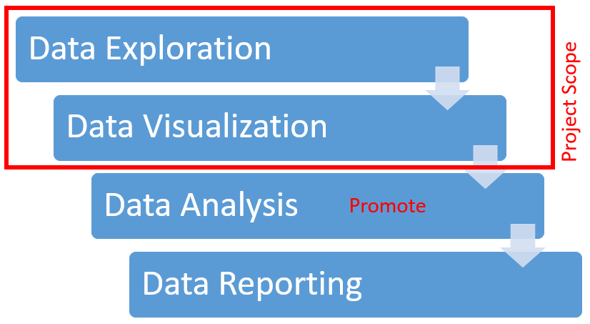

Thirdly, the developed apps were developed in a way so that users can easily manipulate and export data outputs according to their own needs. This gives freedom to users when they decide to conduct further analysis based on app outputs. Please see Figure 3 for more details of this objective.

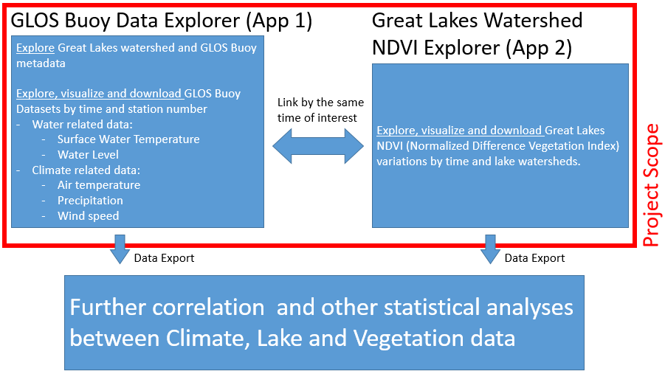

*Figure 3. Project Scope Refined*

Fourthly, we sincerely hope that by utilizing my apps, people would pay attention and begin to conduct preliminary studies on the complex relationships between climate, vegetation within Great Lakes’ watersheds and the lake water surface dynamics. Once, the relationship is understood with the help from my apps. It is also my hope that there would promote more actions of protecting and restoring the vegetation within the Great Lakes watersheds. Although, from pure speculation, I suspect that the vegetation would have a positive impact on mitigating climate change factors on lake surface dynamics.

**Data Sources Used**

At the initial data exploration introduction stage, it was designed as the educational/background component to the users. Thus, static datasets were utilized for users to understand better the Great Lakes watersheds, the lake names, and corresponding. These data sources were from the Great Lakes Information Network, specifically from “**Great Lakes Region Major Lake Basins**”, and its scales varies from 1:250000 to 1:2000000. Also included in this initial stage, I believe it would be a good idea to give an introduction on all metadata on Great Lakes buoys, thus **“GLOS Observation Data”**, specifically the list of all available buoys, was also utilized in the background section.

After the initial introductions on the Great Lakes, interactive data exploration first begins with observational data from each GLOS stations (users can select which station they want), these source data are specifically from the **time series data from sensors at each buoy** in question. It is worth mentioning that for demonstration purpose, only air and water temperature data from **station 45024** is utilized here, but this project was designed to be capable of handling all GLOS buoys data. Also, **station 9087096** **from NOAA CO-OPS program** was also included in this app, because of the long durations of data records available from this station.

Second interactive data exploration begins with the NDVI app, which is closely related to the NDVI datasets from Landsat 5, 7 and 8 data. These data were initially referenced from the USGS/NASA Landsat Program by satellites, and then archived and later processed by Google Earth Engine. Specific data utilized in the app includes the **Landsat 5, 7 and 8 TM 8-Day and 32-Day NDVI Composites**. Users have the option to choose any dataset mentioned above as they see fit as the app inputs.

**Access and testing instructions for my submission**

1. GLOS Buoy Data Explorer (Developed based on R Shiny Platform):
   1. Access: User need to first install the R software and also the R studio desktop software. The links to both software can be found at <http://cran.mtu.edu/> and <https://www.rstudio.com/products/rstudio/download2/#download>. Upon successful installation of both software, you would need to install the three R packages necessary for running the app. These packages include shiny, zoo, and xts. In order to install and load these packages, you need to open R studio type in the following codes into the console (bottom left window), then hit enter on your keyboard:

ipak <- function(pkg){

new.pkg <- pkg[!(pkg %in% installed.packages()[, "Package"])]

if (length(new.pkg))

install.packages(new.pkg, dependencies = TRUE)

sapply(pkg, require, character.only = TRUE)

}

packages <- c("shiny", "zoo", "xts")

ipak(packages)

Once the packages are installed, please download all files from the link below and extract the files to your desktop:

<https://drive.google.com/folderview?id=0B0UZcqs_p5tYjVJUlNlcHZRQm8&usp=sharing>.

Then find and click on the “Files” tab on the bottom right window of R Studio. Find and click “…” button, which is one line below the “More” option button. A window titled “Browse for Folder” will appear, you should select and click on “Desktop”, and then click “OK” towards the bottom of the window. Then the window disappears, and then you should be able to see the list of extracted files appear under the “Files” tab mentioned above. When you get to this point, you are very close to launching my application. Back to the list of files shown under “Files” tab, you should first click on “data3.RData” to load all data necessary for the app. After that, you shall click on the three files “global.r”, “server.R”, and “ui.R”, order does not matter in clicking these files. Then, please locate and click on the “Run App” button in the top left window, it should look like . A window will now pop up and showing the app interface. Lastly, please locate and click on the  button near the top of the popped window. Finally, you would see my app displayed in your web browser.

* 1. Testing instructions:
     1. Upon reading through the instructions, you shall first begin your GLOS Buoy Data Exploration from the left panel.
     2. In the first interactive map on the left panel, you can explore the various Great Lakes’ watershed to discover their various lake basin names and areas by clicking on them.
     3. In the second interactive map below, you can explore the discover all GLOS buoy dataset. By clicking on individual buoy locations, you can be able to learn how long was the data recorded at that buoy, buoy ID information and other important buoy related metadata.
     4. Upon initial explorations in the above maps, you can start to investigate individual time series data from sensors located on each GLOS buoys. (For demonstration purpose, this app now only includes data from GLOS station 45024 and NOAA CO-OPS 9087096 air and water temperature datasets.)
     5. You can start by inputting start date, end date and station number of your interest. **Please keep in mind that Station 45024 has available data from 2012/5/1 to 2015/11/3, and Station 9087096 has data records from 2008/1/2 to 2016/1/1. Please input your start data and end date according to these data availabilities.** Otherwise, errors would appear to show no available data.
     6. Once you have input your desired parameters into the three fields, you can hit “Submit” button. Then static visualizations would appear on the right side of the panel. Four charts would appear, top two show charts generated from raw hourly air and water temperatures based on your defined parameters on left. Third and fourth charts show daily aggregated air and water temperatures from the raw hourly data.
     7. Once the four charts are successfully displayed on right, you can export data included in each of the four charts by clicking on the buttons beneath each chart. By clicking on the buttons, you can download chart data as csv file for your further analysis.

1. Great Lakes Watershed NDVI Explorer (Developed based on Google Earth Engine Platform):
   1. Access: Users can visit the link below directly for access to this app, no software installations are needed.

<https://code.earthengine.google.com/7a0e6264c6b68935025783c74eece1c3>

You must have a Google account to access this app, and also please make sure your account is registered with the Google Earth Engine through the link below:

<https://signup.earthengine.google.com/#/>

* 1. Testing instructions:
     1. Please find the code editor section near the top of the page, see below:



Begin with line 2 first. The letter within the quotation marks represents the NDVI source dataset you could select as the input for this app. Please see below for a list of possible data sources you can utilize in this app:

|  |  |  |  |
| --- | --- | --- | --- |
| Input Text | Dataset Name | Data Availability | Description |
| LANDSAT/LT5_L1T_8DAY_NDVI | Landsat 5 TM  8-Day NDVI Composite | Jan 1, 1984 –  May 8, 2012 | [link](https://code.earthengine.google.com/dataset/LANDSAT/LT5_L1T_8DAY_NDVI) |
| LANDSAT/LT7_L1T_8DAY_NDVI | Landsat 7 TM  8-Day NDVI Composite* | Jan 1, 1999 –  Aug 12, 2016* | [link](https://code.earthengine.google.com/dataset/LANDSAT/LE7_L1T_8DAY_NDVI) |
| LANDSAT/LT8_L1T_8DAY_NDVI | Landsat 8 TM  8-Day NDVI Composite | Apr 7, 2013 –  Aug 12, 2016 | [link](https://code.earthengine.google.com/dataset/LANDSAT/LC8_L1T_8DAY_NDVI) |
| LANDSAT/LT5_L1T_8DAY_NDVI | Landsat 5 TM  32-Day NDVI Composite | Jan 1, 1984 –  May 8, 2012 | [link](https://code.earthengine.google.com/dataset/LANDSAT/LT5_L1T_32DAY_NDVI) |
| LANDSAT/LT7_L1T_8DAY_NDVI | Landsat 7 TM  32-Day NDVI Composite* | Jan 1, 1999 –  Aug 12, 2016* | [link](https://code.earthengine.google.com/dataset/LANDSAT/LE7_L1T_32DAY_NDVI) |
| LANDSAT/LT8_L1T_8DAY_NDVI | Landsat 8 TM  32-Day NDVI Composite | Apr 7, 2013 –  Aug 12, 2016 | [link](https://code.earthengine.google.com/dataset/LANDSAT/LC8_L1T_32DAY_NDVI) |

* Landsat 7 experience a sensor malfunction starting on May 31, 2003. We advise not to use Landsat 7 after that date.

* + 1. Once you have decided on the input dataset name, please change it accordingly within the quotation marks on line 2 of the code.
    2. Then on line 3, please change the start and end dates of your interest according to the data availability of the source you have selected above. Please check this with the table above.
    3. On line 4, please change the lake basin to match your interest.
    4. Click on after you have made all of the changes above. Then you will see a map of the watershed displayed on the map to the right of the screen.
    5. Click anywhere on the map, and you will see a chart being generated on the bottom left of the app. This graph shows average NDVI across the entire watershed variations overtime you have elected. 8-days composites display weekly variations, and 32-days composites display monthly variations.
    6. Lastly, click on  to the top right of the new chart generated. You can then zoom on the chart and also download data from this chart in a new tab.

**Correspondences with GLOS personnel and experts on necessarily to linking to NDVI dataset**

*My Question:*

- is there a need to ask index the vegetations within the great lakes watershed?

- is there a need to correlate the vegetation index with GLOS water datasets?

*Ms. Rebecca Pearson, Program Manager:*

“Overall, I think so.”

*Dr. Charlotte Roehm, GLOS Expert:*

“Yes – I believe so. NDVI can be used to map nearshore vegetation and land-use patterns and measures of vegetation vigour to help evaluate lake surface dynamics in relation to the catchment's response to variations in weather and climate. These will in hand determine the variability in the water cycle dynamics and is ability to provide information on the impact of vegetation/land-use in these regions on the localized variability in water levels in response to weather patterns. Understanding the input parameters to near-shore regions, particularly from a physical water mass balance perspective, combined with the physical, biological and chemical composition of nearshore regions, could potentially help with predicting events such as hypoxia and algal blooms, problems increasingly experienced in the Great Lakes with changing water levels and temperatures. Further, this will have important implications for the ReCON network to allow for continual assessment of the status and trends in coastal environments in order to identify perturbations that may signal changes in the ecosystem, comparing current trends within a historical framework, allowing one to differentiate true environmental change from variance, and providing context to assess the impact of predicted changes.”